Case Study FedEx shipping price not showing on the cart page

Client Name: Anan Shehab
Client website URL: https://karamproduct.com/

1. Overview:
With the FedEx Shipping Method, your shoppers at checkout will see and be charged for shipping based on your FedEx rates. The rates are determined via the FedEx API.

2. What was the challenge to troubleshoot the issue
Troubleshooting the issue of FedEx shipping prices not showing on the cart page in an eCommerce platform can be a challenge, but by following a systematic approach, you can identify and address the problem.
Shipping Method Configuration.
API Credentials.
Shipping Zones and Rules.
Product Settings.

3. What were the solutions to fix this issue
If FedEx shipping prices are not showing on the cart page of your website, there could be a few reasons for this issue:
Go to: WooCommerce > Settings > Shipping > FedEx.
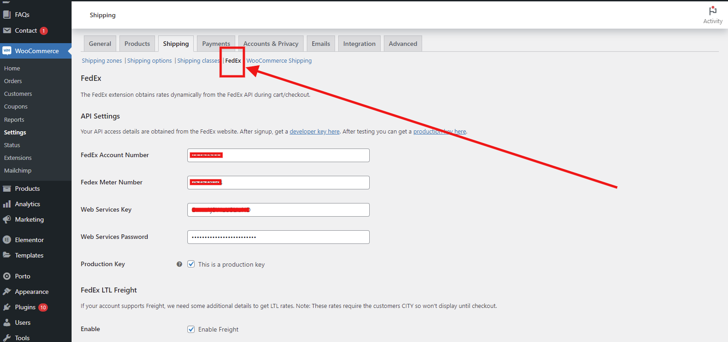

API Settings – Please fill in all the details correctly

Your API access details are obtained from the FedEx website. After signup, get a developer key here. After testing you can get a production key here.
FedEx Account Number:-------------?
FedEx Meter Number:------------?
Web Services Key—-----?
Web Services Password—----?

Go to: WooCommerce > Settings > Shipping:
Select the Shipping Zone that you want to add the method to, hover over the Zone name, and click the Edit link:
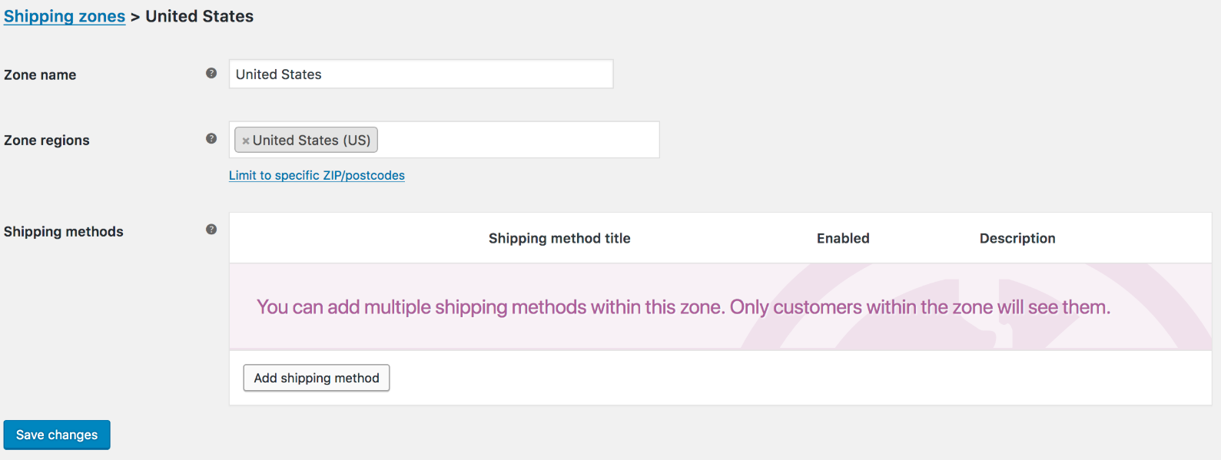
Click the Add Shipping Method button:
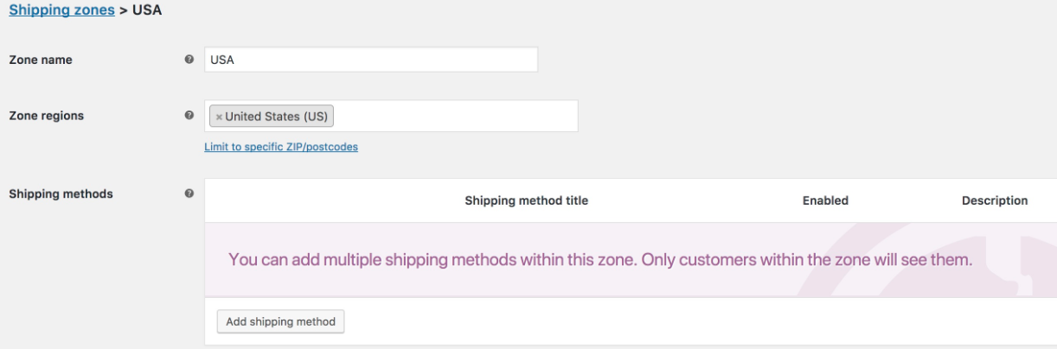

Select FedEx from the dropdown and press Add shipping method:
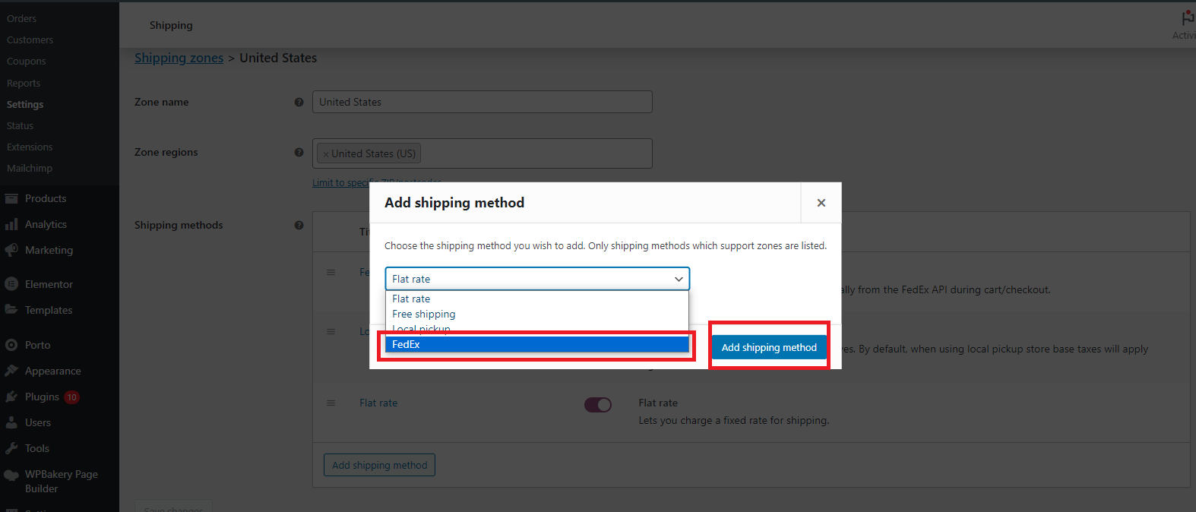

Now add your postal code
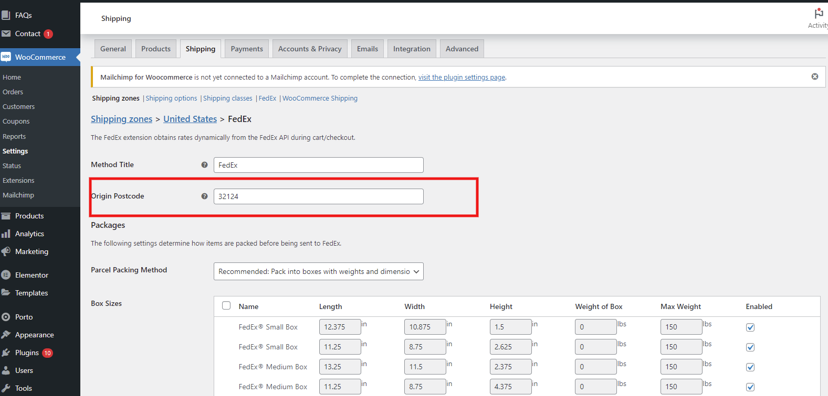

You can manually rearrange the order of FedEx services by selecting the icon:
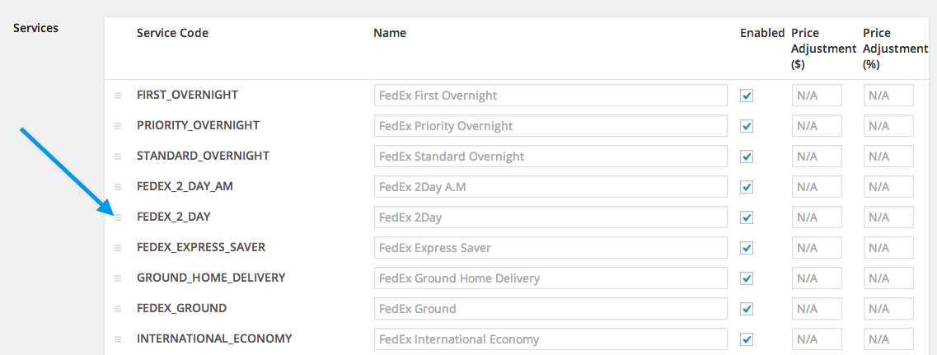
Save your settings.

This is what the customer sees on the front end:
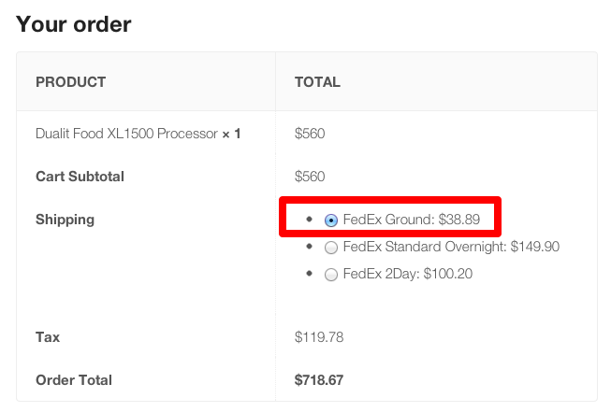

4. Conclusion
In conclusion, the case study highlighted the challenges faced by an e-commerce website when the FedEx shipping rate is not displayed correctly during the cart and checkout process. Through a systematic investigation and troubleshooting process, the root causes of the issue were identified and resolved, leading to a successful outcome.

